Truth as the Stable Eigenstate of Reasoning

Abstract: This work develops a synthesis between classical logic and dynamical systems theory. The canonical inference square – Modus Ponens (MP), Modus Tollens (MT), Affirming the Consequent (AC), and Denying the Antecedent (DA) – admits a natural interpretation as a stability matrix. Valid inferences (MP, MT) act as negative-feedback eigendirections, damping error and converging toward a stable attractor: truth. Fallacies (AC, DA) operate as positive-feedback eigendirections, amplifying error and driving divergence. The symmetry parallels James Clerk Maxwell’s On Governors (1868), where perturbations may diminish, grow, or oscillate with increasing or decreasing amplitude depending on feedback sign and eigenvalue placement. Framed this way, Aristotle’s concern with valid inference, Maxwell’s concern with mechanical stability, and the modern eigenvalue criterion of dynamical systems are recognized as structurally isomorphic descriptions of reality.
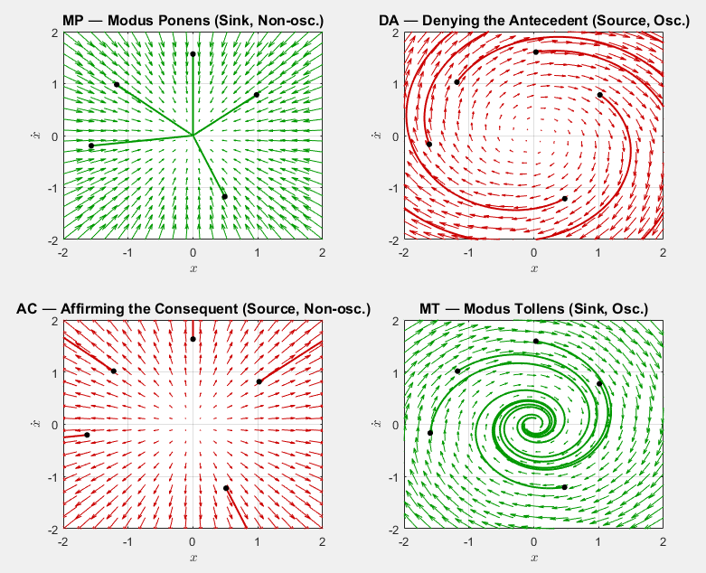

- Foundations:
- Historical Anchors
- Aristotle on motion, necessity/sufficiency, and falsification.
- Galileo on inertia and falsification of Aristotelian motion.
- Maxwell’s On Governors (1868) as the birth of control theory.
- Peirce: Truth as the stable outcome of inquiry (I formulated this too before ever seeing Peirce’s work)
- Core Thesis & Posture of Inquiry
- Aim: Seek truth through coherence and invariance rather than stacking “facts.”
- Posture: Epistemic humility (be willing to be wrong) + deontological doubt (moral duty to avoid false positives) + ontological confidence (reality has structure, which can be probed).
- Truth framing: Truth is what survives inversion; in dynamical terms, it behaves like an attractor—an equilibrium a good model converges toward under perturbation and feedback.
- Ethic: Prefer a non-answer to a confidently false answer. Minimize doubt; don’t enshrine beliefs.
- Aphorisms:
  - “Truth is what survives inversion.”
  - “Belief insists. Truth persists.”
  - “Error is acceptable; fragility is not.”
  - “A tool, not a totem.” (method over tribe/brand)
  - “Don’t fear being wrong, fear not being informative.”
  - “Invite error, reject fallacy.”
  - “Maximize error, minimize fallacy.”
  - “Plan for failure (accept false positives)”
  - “Anything that can happen, will happen.”
  - “Only those who risk are free.”

- Logic as Structure:
- Validity, Soundness, and the Truth Matrix (2x2 Inference Square)
- Valid: If the premises were true, the conclusion couldn’t be false (form guarantees truth-preservation).
- Sound: Valid + premises actually true ⇒ conclusion true.
- Quick check: if you can imagine “true premises + false conclusion,” the argument is invalid.
- Modus Ponens (MP – sufficiently valid)
- Modus Tollens (MT – necessarily valid)
- Affirming the Consequent (AC – fallacy)
- Denying the Antecedent (DA – fallacy)
- Truth isn’t just an abstract ideal, it’s the stable eigenstate.
- Diagonal Principle:
  - Truth Diagonal = stability eigenspace (MP, MT).
    - Sound reasoning (MP, MT) is the negative feedback operator that damps error and aligns the trajectory with that attractor.
  - Fallacy Diagonal = instability eigenspace (AC, DA).
    - Fallacies (AC, DA) are the positive feedback operator that destabilizes, amplifies error, and diverges from truth.
- Distinction: valid vs sound
- Language discipline: “consistent with,” “rules out,” “under assumptions.”
- Error Policy & Inquiry Ethics
- Asymmetry of Error (false positives worse than false negatives, accepting what’s wrong is costlier than missing what’s right)
- Ethical duty: prefer non-answers to confident errors.
- Deontological knowledge vs stacked provisional knowledge (TES): prefer structural coherence over piling agreeable claims.
- Huxley (rational vs non-rational propaganda):
  - Rational = evidence + logic, welcomes diverse probes and feedback.
  - Non-rational = slogans, selective replication, avoids diverse probes.
- Deontological doubt: pre-register kill conditions (what would change your mind).

- Method of Inquiry:
- TES Riddle of Certainty -> Order of Operations
- Make it Probative, Then Make it Reliable
- B: many perspectives once > A: one perspective many times.
- B (probative): many perspectives once → a discriminative signature that alternatives struggle to pass.
- A (reliable): same signature, replicated across time/context.
- Ethical inquiry: do B first (diverse, discriminative), then A (repeat that same signature).
  - Like digging a deep and wide hole by hand, you start by going wide, not by going deep.
- Unethical inquiry: cling to A (repeat a single friendly probe), avoid B.
- Reject or Revise if any necessary condition fails.
- Geometry as Critical Path Metaphor (Sets → Lens → Triangle)
- Treat propositions as regions; necessities define loci.
- Triangles — analogy as structural similarity, preserved under inversion.
- Analogies as similar triangles (preserving structure under inversion).
- Visual scaffolding for designing and testing constraints.
- Sets → lens → triangle.
  - two independent loci intersect to form a region; add a cut to isolate.
- Two loci intersecting, tie-breaker cut.
- Route A (distance/absolutes): Two independent constraints → a lens with two candidates; add a small cut to select one.
- Route B (ratio/relational): One relational constraint (Apollonius-style contrast) + one absolute → two candidates → small cut → one.
- Why it helps: Forces you to ask, “What must hold if PP were true?” and to plan two independent necessities plus a final tie-breaker.
- Analogies & triangles: You visualize sound analogy as similar triangles (shape preserved under inversion), not a decorated parallelogram.
- “Lune”/lens: the intersection area you shrink via recursion until a unique solution remains.
- Acceptance Gate: ≥2 independent necessary checks + 1 directional cut (an inequality/orientation/extra fact) to break symmetry and resolve degeneracy. (MT leverage)
- Orthogonality rule: independence of probes, checks must fail for different mechanisms (no hidden common cause).
- Working habit: Invert → Fold → Recurse → Decide.
  - Invert (list necessities), fold (intersect evidence), recurse (tighten/add third constraint), decide (only if it survives diversity + repetition).

- Dynamics of Truth
- Truth as an Attractor - reasoning converges when feedback is negative, diverges when positive.
- Iterative inversion/feedback tends to stable structure; divergence under stress indicates brittleness.
- Disturbances and Feedback: negative feedback converges, positive diverges.
- Closed-loop vs open-loop:
  - Open-loop ≈ MP-only assertions (no correction).
  - Closed-loop: observe → compare → adjust; MT is the error signal that triggers revision.
- Implicit vs explicit claims: Treat claims as implicitly defined; refine until convergent; non-convergence is itself diagnostic (wrong model class, missing variable).
- Maxwell, Eigenvalues, and Inference Stability (NEW)
- Maxwell’s four motion types:
  - Disturbance ↑ → AC (divergence).
  - Disturbance ↓ → MP (monotone convergence).
  - Oscillation ↑ → DA (unstable swing).
  - Oscillation ↓ → MT (damped convergence).
- Map to inference square:
  - MP = diminishing disturbance (stable convergence).
  - MT = oscillatory decay (stable convergence).
  - AC = disturbance grows (error divergence).
  - DA = oscillatory growth (unstable swings).
- Eigenvalue framing:
  - Valid inferences = |λ| < 1 (negative feedback, stable eigen-directions).
  - Fallacies = |λ| > 1 (positive feedback, unstable eigen-directions).
  - Complex λ = oscillatory reasoning (DA, MT).
  - Truth = the stable eigenstate of reasoning.

- Practice & Application
- Everyday Examples (ISP diagnosis, rain vs sprinklers, batteries, LEDs).
- ISP vs my setup (everyday):
  - B: router admin page reachable but no external sites; Wi-Fi & Ethernet both fail; ping router OK/public IP fails; cut: LTE loads sites → points upstream.
  - A: repeat after reboot + 15 min; optional neighbor corroboration.
- LED dark because switch open (technical):
  - B: switch continuity open; LED lights when switch bypassed; supply across switch.
  - A: repeat after reseat / on another board; cuts: polarity and LED known-good.
- Batteries in remote (simple):
  - B: dim/absent LED; multiple buttons fail; IR not visible on phone camera; cut: TV responds to front panel/another remote.
  - A: swap known-good batteries and retest later.
- Rain vs sprinklers (canonical):
  - B: exposed vs covered contrast; roof beading; both sides of street; cut: weather radar/LTE check.
  - A: replicate two blocks away.
- Technical Examples (breadboards, circuits, governors)
- Seasonal Mnemonic (optional)
- Summer—Observe ☀️ (comfort & stagnation)
- Fall—Analyze 🍁 (honesty & humility)
- Winter—Reconfigure ❄️ (revelation & apocalypse)
- Spring—Explore 🌱 (growth & doubt)
- A memory hook only; the method is primary.

- Robust vs Brittle Ideas (multi-check resilience vs single-probe fragility)
- Brittle: single-metric dependence, moving goalposts, selective replication (A-only).
- Robust: invite diverse probes (B) and replication (A); survive inversion, role-switching, recursion.

- Guardrails
- Failure Modes
- Two-constraint rule: never accept on one constraint, however often repeated.
- Orthogonality: checks must fail for different reasons.
- Failure modes to watch:
  - Local coherence $≠$Truth (Goodhart, conspiratorial closure).
  - Hidden dependence between probes.
  - Non-convergence as a signal of wrong model class.
  - Multi-attractor domains (plural truths, conditionality).
- Mitigations: independence checklist; pre-registered stop conditions; report assumptions.
- Cautions & Caveats (honesty preserved)
- Geometry is a metaphor; feedback is structural.
- Independence is difficult, explicit about mechanisms.
- Non-convergence = diagnostic.
- Invariance can be local. Multiple attractors exist; adversarial environments can spoof signatures.
- Independence is hard. Hidden common causes will fool you—be explicit about mechanisms and modalities.
- Non-convergence is information. Sometimes the model class is wrong; update or re-specify.
- Geometry is a metaphor. Keep it in the appendix when teaching; use the acceptance rule first.

- Teaching Artifacts
- Lecture Architecture (50-min template)
- Lecture flow (truth matrix → stability → acceptance rule → case study).
- Worksheet Template (acceptance rule, probes, assumptions, report).
- Worksheet Template ( (claim → assumptions → Q1, Q2 → cut → outcome).
- Imagery and Iconography (lens-and-cut as core; phoenix/tree as editorial).
- Naming and Identity (Peirastes/Peirastikon/Peirastesis, tool not a totem)
- Reporting Style (neutral, non-totemic, falsification-first).
- Language discipline: “consistent with,” “rules out,” “under assumptions.”

- Distinctiveness
- What’s Novel Here
- Bridges logic, control theory, and epistemology.
- Provides a workflow, geometry, and ethics for real-world inquiry.
- Formalizes falsification as operator dynamics.
- Operationalized falsification into a repeatable workflow.
- Geometric planning metaphor.
- Diagonal-eigenstructure synthesis of inference, feedback, and truth.
- Identifies truth as stable eigenstate, fallacy as unstable eigenmode.
- Developed teachable artifacts and aphorisms
This structure now flows pedagogically:
- Foundations (why, posture, history) →
- Logic backbone (what inference is) →
- Method (how to apply probes/tests) →
- Dynamics (stability, Maxwell, eigenvalues) →
- Practice (examples, applications, ethics) →
- Guardrails (failure modes, cautions) →
- Teaching tools (slides, worksheets, imagery) →
- Novelty (what makes this method distinct).

